Cole Otwell
05/04/2020
Computer Organization

Assignment 5

- From lab 12, report on your ALU:
  - Draw the instruction event table for your computer.
  - Collect all the arithmetic and logic micro-operations required in the instruction event table.
  - 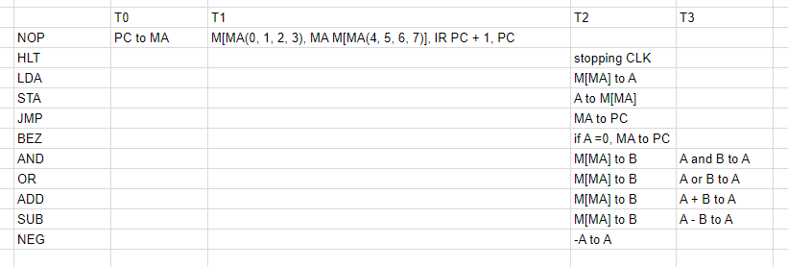
  - Draw the high-level block diagram of the ALU (similar to what I have in my slides) to show its components and connections. You may want to use the draw.io website to do this.
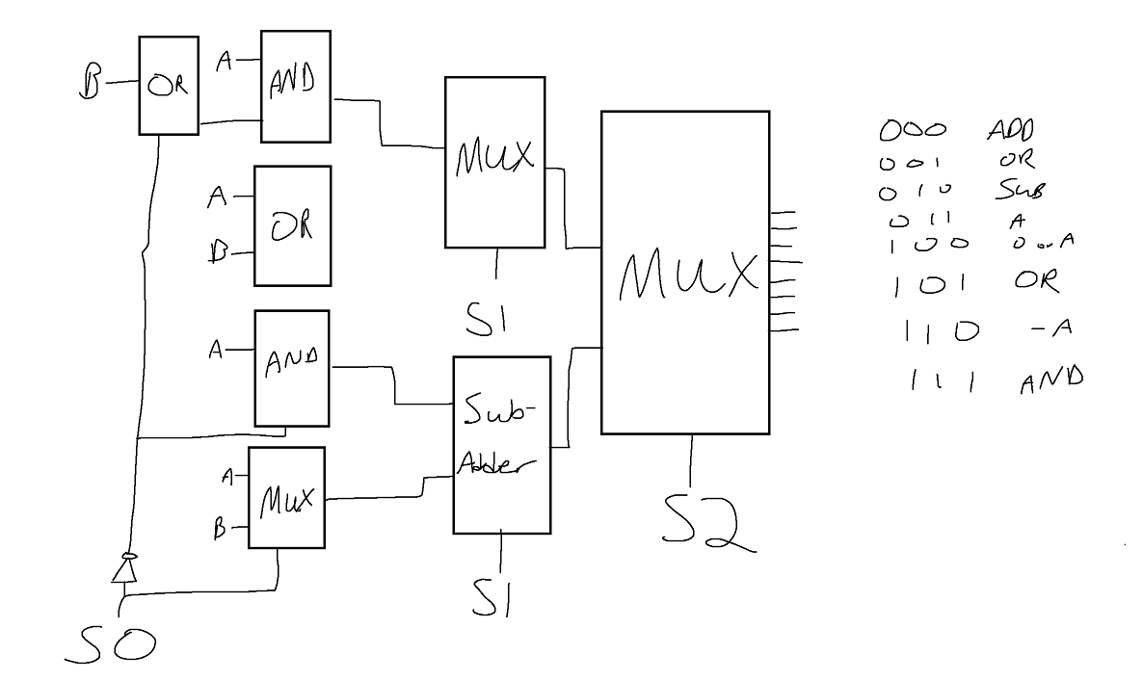
  - Draw the function table for your ALU so that I know which control points need to be set high, for a specific operation.
  - 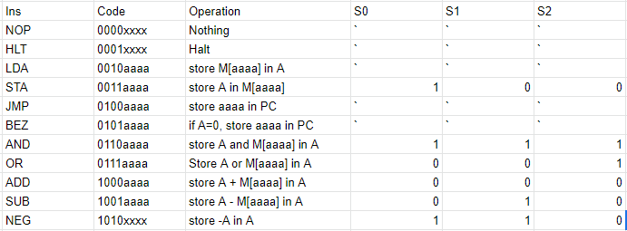
  - Show your implementation of your ALU in LogicWorks, both the packaged and unpackaged variations.
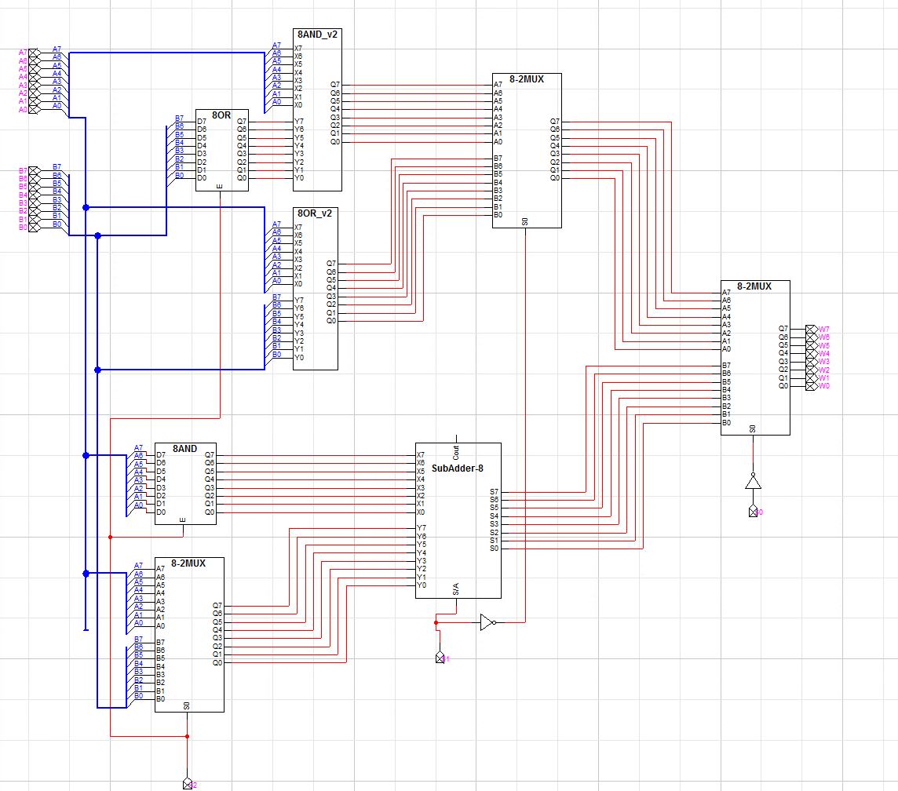

  - Show an annotated waveform or multiple screen captures of your ALU that show each operation working correctly. Note: be sure to demonstrate that the output of your ALU is correct by performing the operation by hand, and including that in your report.
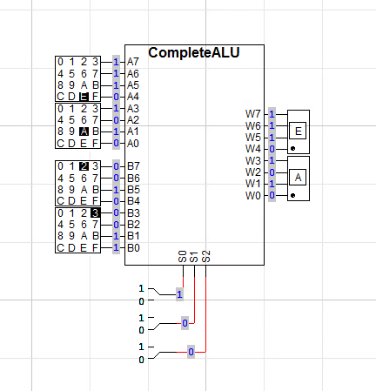
STA operation = code 1 0 0
Just passes A through, so EA is correct
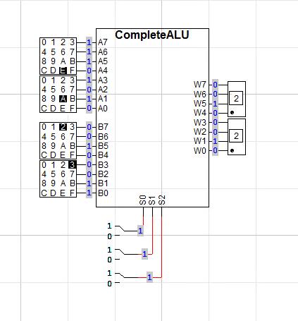
AND operation = code 111
E and 2 = 1110 and 0010 = 0010 = 2
A and 3 = 1010 and 0001 = 0010 = 2
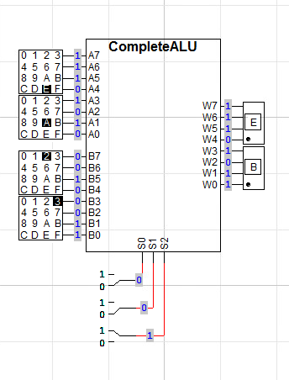
OR operation = code 001
E or 2 = 1110 or 0010 = 1110 = E
A or 3 = 1010 or 0011 = 1011 = B

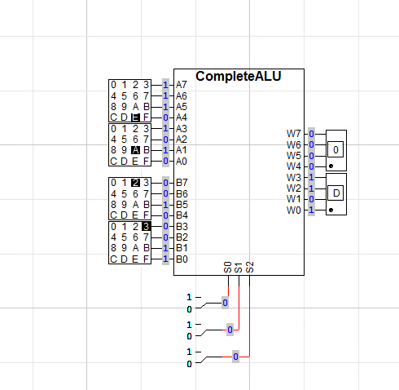
ADD operation = code 000
E + 2 = 0
A + 3 = D
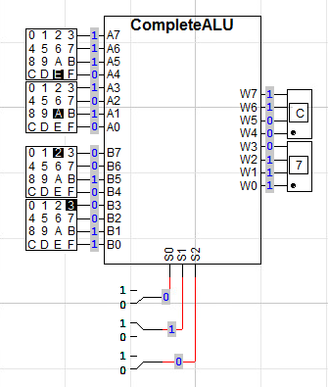
SUB operation = code 010
E - 2 = C
A - 3 = 7
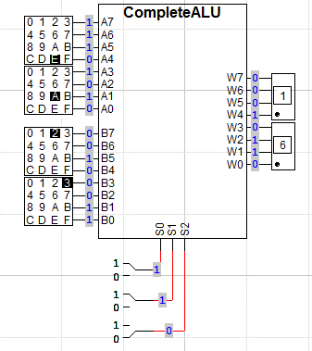
NEG operation = code 110
Negate EAh and you get 16h

- From lab 13, report on your datapath
  - draw the high-level block diagram of the datapath to show its components and connections.
  - List the names of all the control points on the datapath.
  - 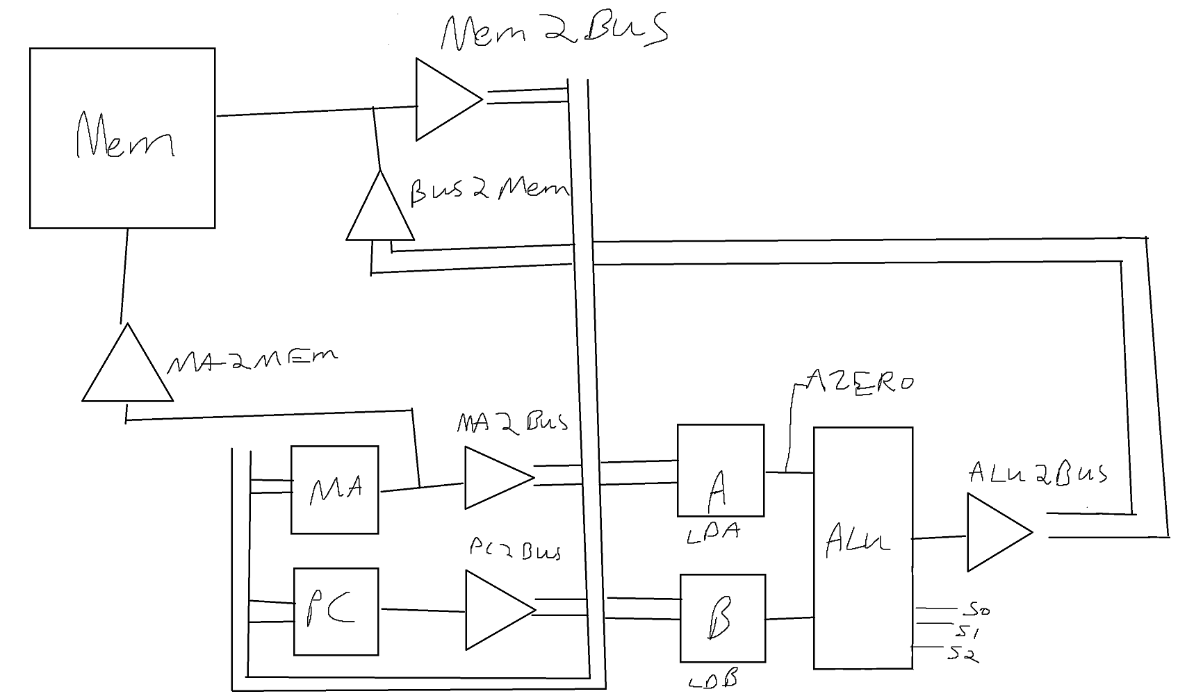
Tristate buffers are the triangles***
~~~~~~~~~~~
MA2BUS
PC2BUS
MEM2BUS
ALU2BUS

LD-A
LD-B
LD-MA
LD-IR

S0..2
  - implement and test the datapath in LogicWorks using your newly designed ALU. Save your datapath in a file called “datapath”. Submit a screenshot of the datapath in LogicWorks, as well as a separate screenshot of an annotated waveform which demonstrates that all control points work as expected.
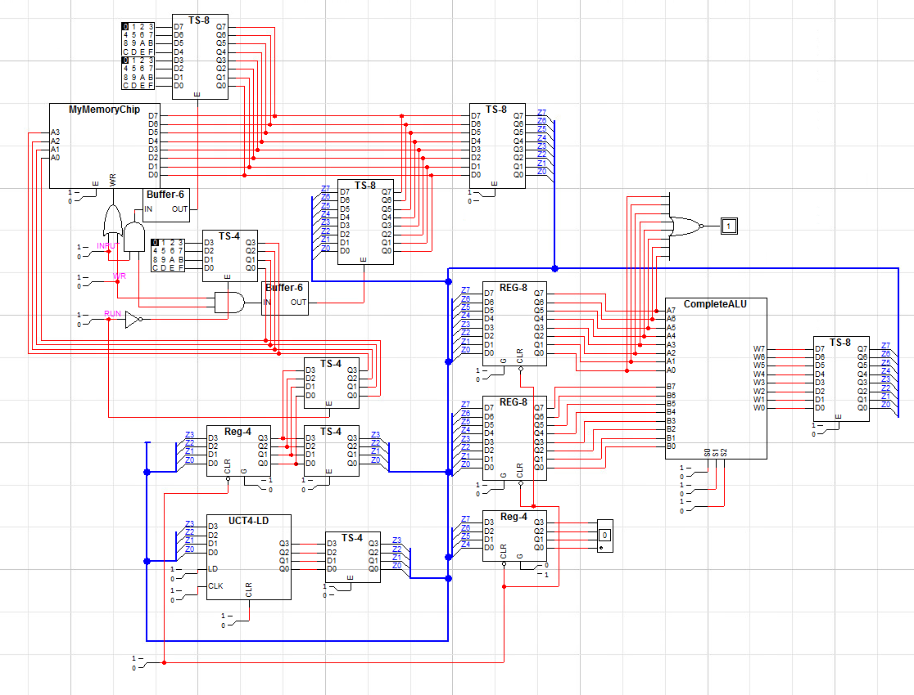
- From lab 14, report on your timing finite state machine
  - draw the state transition diagram of the timing finite state machine for your computer
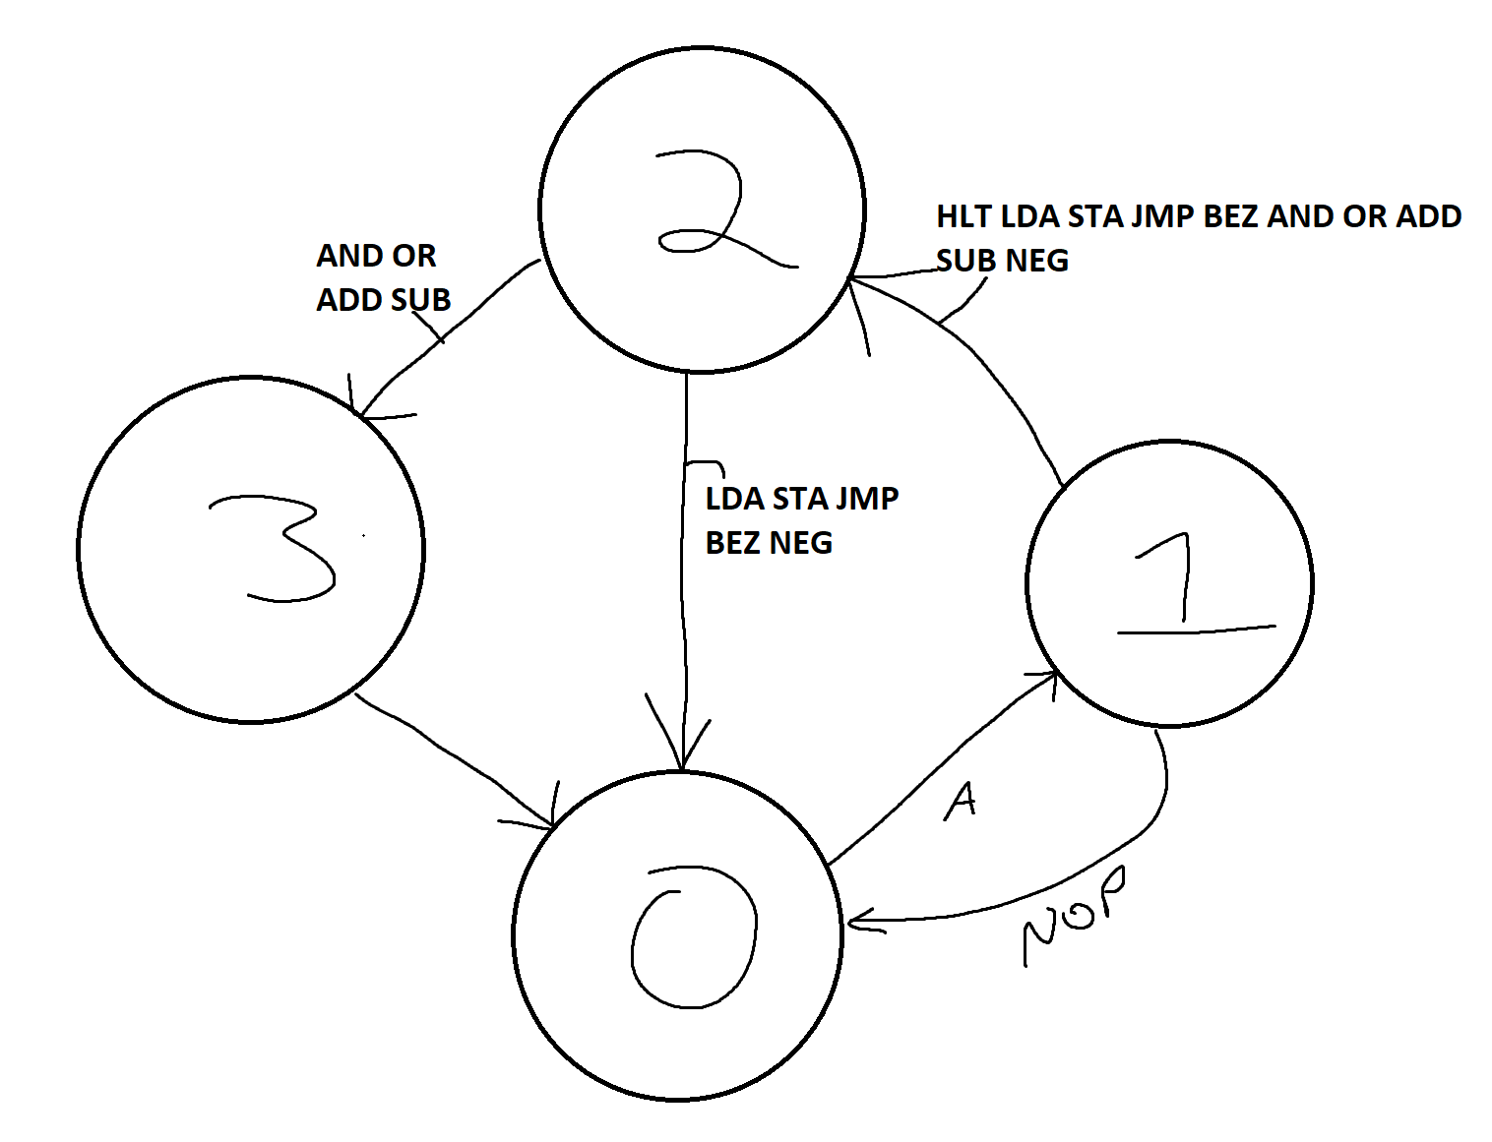
  - Use the “one-hot” method to implement your timing finite state machine as follows:
    - Obtain the Boolean equation for the D input for each D flip-flop in terms of the timing states (T0, T1, T2, T3) as well as the instruction signals (LDA, STA, etc.)
Unsure.
    - Complete the implementation, ensuring a transition to state T0 as the initial state after a master-clear.
Done, it will always transition to state 0 after a clear
  - Test your timing state smaching to ensure that it generates the right timing sequence for each individual instruction. Show your circuit in LogicWorks, as well as an annotated waveform for each instruction.
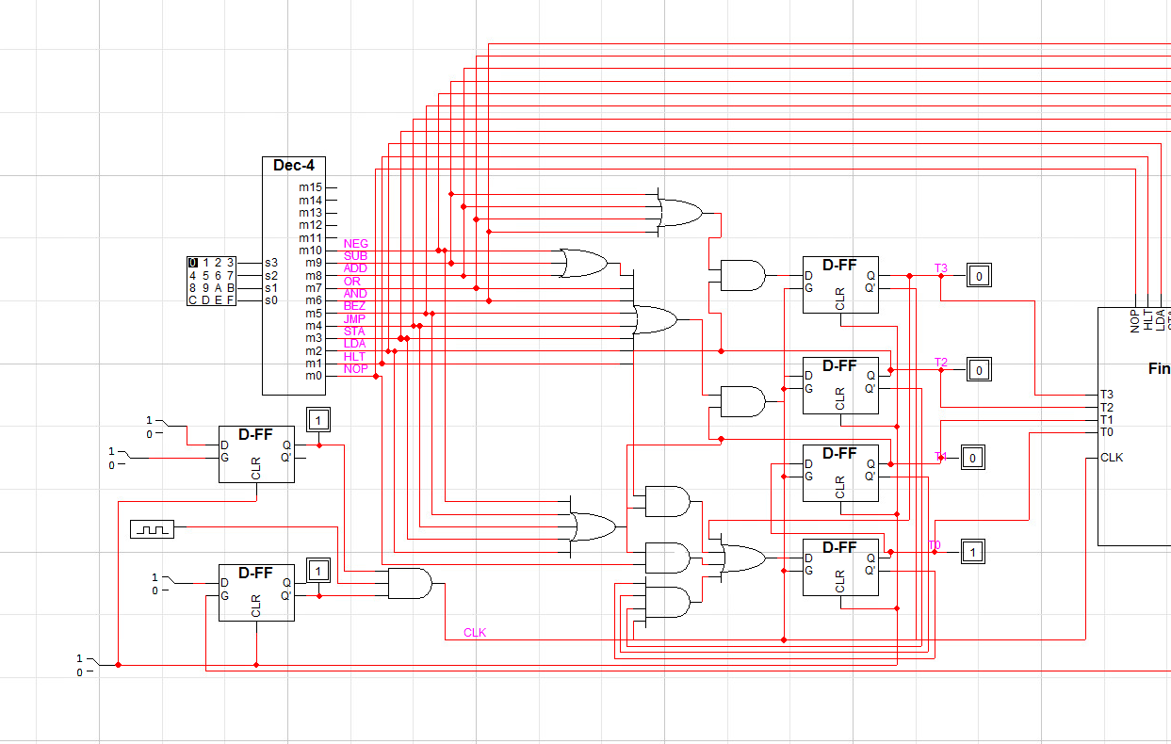
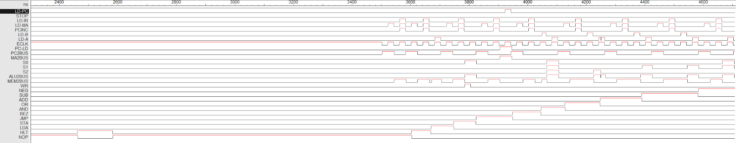
The waveform matches the intended usage from the Instruction Event table at the top of this report.
(numbers = state)
HLT 0 1 2… (waiting)
NOP 0 1
STA 0 1 2
JMP 0 1 2
BEZ 0 1 2
AND 0 1 2 3
OR 0 1 2 3
ADD 0 1 2 3
SUB 0 1 2 3
NEG 0 1 2
LDA 0 1 2

- From lab 14, report on your Control Logic
  - relist the control points of the datapath for your computer.
This is the same as above
~~~~~~~~~~~
MA2BUS
PC2BUS
MEM2BUS
ALU2BUS

LD-A
LD-B
LD-MA
LD-IR

S0..2
  - redraw the function table of the ALU of your computer
  - redraw the instruction event table of your computer
  - Draw the control points activation table for your computer
  - Obtain the boolean equation for each of the control points in the datapath of your computer
LD-A = G(T2(NEG + STA)+T3(OR + ADD + SUB + AND))
LD-B = G(T2(OR + ADD + SUB + AND))
LD-MA = G(T0 + T1)
LD-IR = G(T1)
LD-PC = G(T1)
MEMBUS = T1 + T2(LDA + OR + ADD + SUB + AND)
ALU2BUS = T2(NEG + STA) + T3(OR + ADD + SUB + AND)
MA2BUS = T2(JMP + BEZ)
PC2BUS = T0
PCLD = TS(JMP + BEZ)

S0 = T2(NEG + STA) + T3(AND)
S1 = T2(NEG) + T3(AND + SUB)
S2 = T3(AND +OR)
  - Implement and package your control logic using the boolean equations above. Be sure to use AND gates with ECLK (the complement of CLK) for the register load control points such as LD-A, LD-IR, etc. Show this circuit.
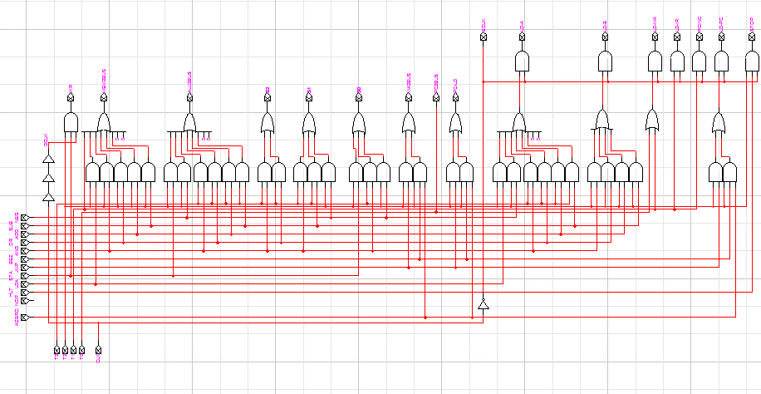
  - Connect the control logic with the timing finite state machine you created above. Show the connected circuit.
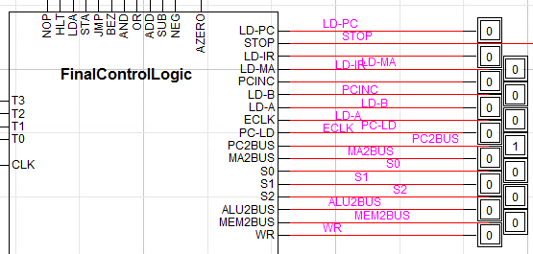
  - Test the entire control unit by observing the waveforms of all the control points for each individual instruction. Submit an annotated version of this waveform.
  - 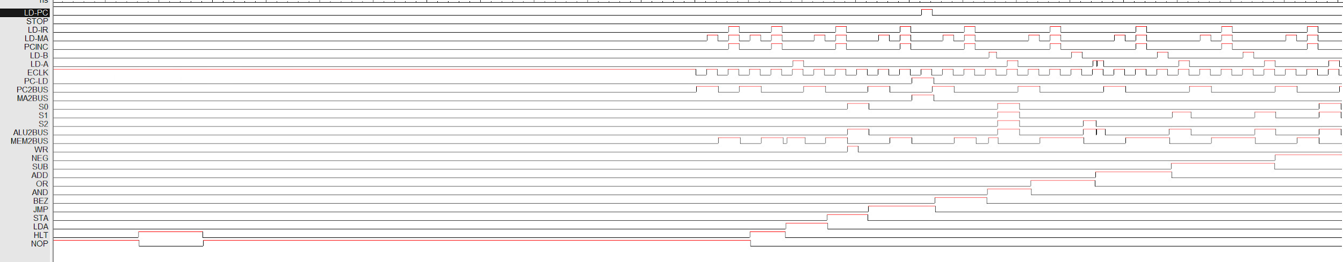
Same as above, included entire waveform
- From lab 15, report on your small computer
  - Connect your tested datapath with the tested control unit to form your computer. Submit an image of the computer.
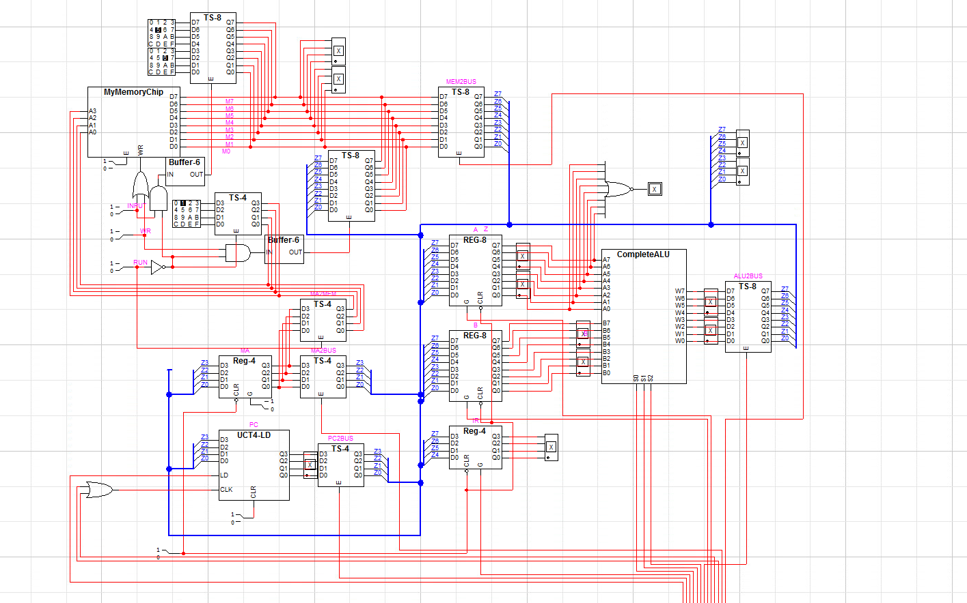
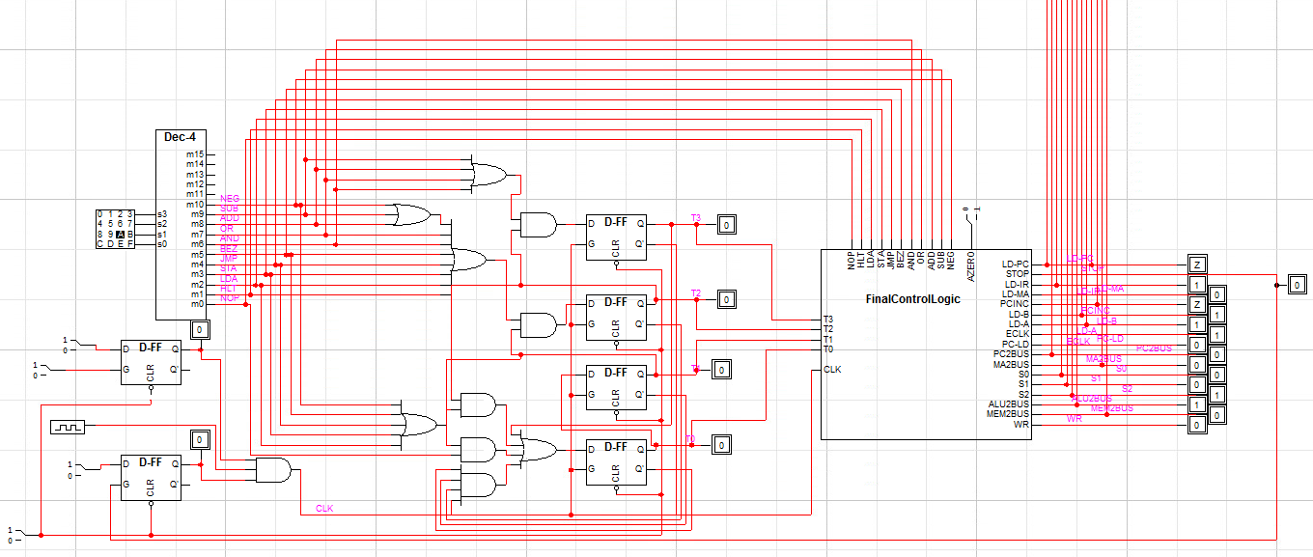
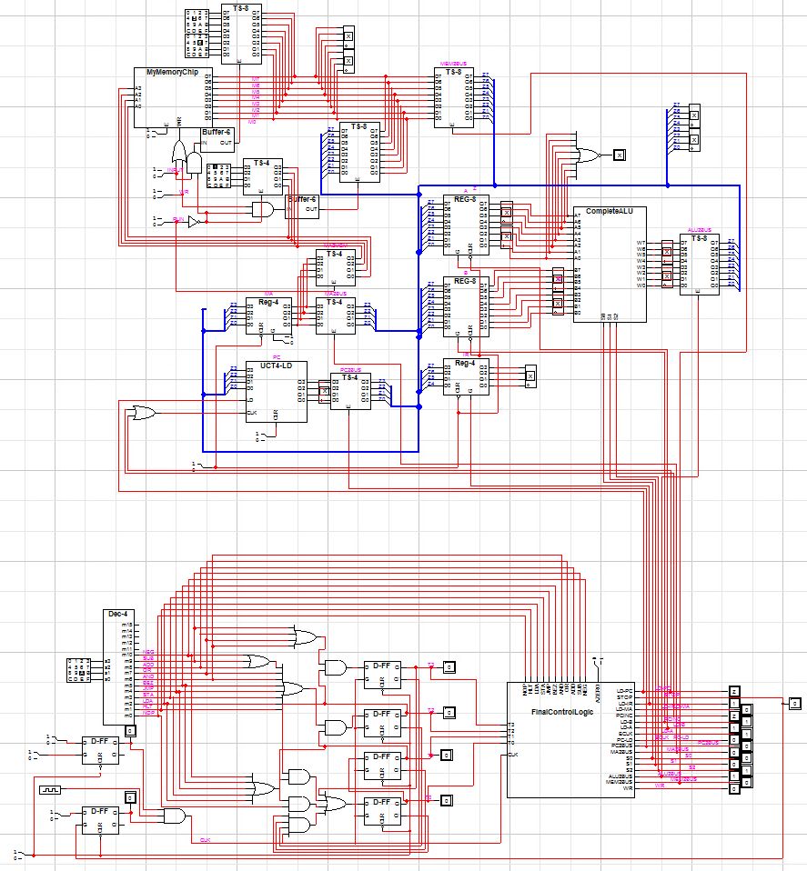
(Unsure how to get a clearer picture of the entire schematic)
  - Test your computer by running the following programs using the following steps:
    - Translate this program to machine code, including the address of each instruction and data. Submit this translation

(I am able to translate this to machine code, but I failed to be able to input this data in. No matter what I did, I was always ending up with various X’s everywhere. I think I missed a connection or something overlapped, but everything was working when I was testing all the various circuits separately so I assume it was just a build error.)

prog1:
LDA | 0 | 0010 [0100] | 24
NEG | 1 | 1010 [0000] | A0
NOP | 2 | 0000 [0000] | 00
JMP | 3 | 0100 [0001] | 42
X | 4 | 0000 [1101] | 0D

Prog2:

LDA | 0 | 0010[1011] | 2B
BEZ | 1 | 0101[1001] | 59
LDA | 2 | 0010[1010] | 2A
ADD | 3 | 1000[1011] | 8B
STA | 4 | 0011[1010] | 3A
LDA | 5 | 0010[1011] | 2B
SUB | 6 | 1001[1100] | 9C
STA | 7 | 0011[1011] | 3B
JMP | 8 | 0100[0000] | 40
HLT | 9 | 0001[0000] | 10

Prog3:

LDA | 0 | 0010[1000] | 28
SUB | 1 | 1001[1001] | 99
NEG | 2 | 1010[0000] | A0
ADD | 3 | 1000[1011] | 89
AND | 4 | 0110[1010] | 6A
OR | 5 | 0111[1011] | 7B
STA | 6 | 0011[1100] | 3C
HLT | 7 | 0001[0000] | 10

That should be all the machine code, might have missed something there since I was not able to test it on the actual computer that I built (errors).

    - Load the machine code into the memory program manually using the “RUN” switch.
    - Test the machine to run this program correctly by observing the waveforms of the control points and the changes of the register contents.
    - Submit an annotated version of the waveform.
Program 1 |  |  | Program 2 |  |  | Program 3
 | LDA x |  | g: | LDA y |  |  | LDA x
g: | NEG |  |  | BEZ h |  |  | SUB y
 | NOP |  |  | LDA x |  |  | NEG
 | JMP g |  |  | ADD y |  |  | ADD y
x: | 13 |  |  | STA x |  |  | AND z
 |  |  |  | LDA y |  |  | OR w
 |  |  |  | SUB z |  |  | STA u
 |  |  |  | STA y |  |  | HLT
 |  |  |  | JMP g |  | x: | 57
 |  |  | h: | HLT |  | y: | -9
 |  |  | x: | 0 |  | z: | xF3
 |  |  | y: | 4 |  | w: | xCC
 |  |  | z: | 1 |  | u: | x00
NOTE:: xF3 means the hexadecimal number F3

SUBMIT YOUR FINAL DOCUMENT AS A SINGLE PDF FILE!
Your grade will largely be based on complete, detailed, and accurate answers to all questions on this assignment, along with accurate and complete images of your circuits and graphs. You should write your solution like your are explaining, in detail, all of the graphs and images to someone who does not understand. Put in ample detail to show that you truly understand what is happening. Everything that you learned about the topics in this assignment should be apparent in the document you submit!

